Database homework 1

Mingrui liu

1. What is a database management system?

Database management system is a complex software system whose task is to manage a large, complex collection of data. It contains information about a particular enterprise .It allows users to define, manipulate, retrieve and manage data in a database. There are many popular DBMS like Relational (MySQL), Graph Database (Neo4J), Key/Value- data structure store (Redis)

Document (CouchDB)

What are 5 reasons people use DBMS?

* It avoids data redundancy and inconsistency and It makes user to access data easily.
* It allows multiple files and formats, and solve the integrity problem, makes easy to ass new constrains.
* It allows atomicity of updates, avoids partial updates on single data file.
* It allows concurrent access by multiple users.
* It make the database more secure.

2. How do DBMS ensure atomicity?

An atomic transaction is an indivisible and irreducible series of database operations such that either all occur, or nothing occurs.

Consider a transaction that consists of updates to multiple tables. To guarantee atomicity, the DBMS software must be able to ensure that ALL updates within the transaction are committed to the database, or NONE of the updates are committed to the database.

To insure the atomicity, DBMS need to indicate which transaction have started and which transaction have finished. Using “read-copy-update” to keep a copy the date before any update.

3. What is an ER model?

Entity-Relationship data model

The ER data mode was developed to facilitate database design by allowing specification of an enterprise schema that represents the overall logical structure of a database.

* It is a high-level data model. This model is used to define the data elements and relationship for a specified system.
* It develops a conceptual design for the database. It also develops a very simple and easy to design view of data.
* In ER modeling, the database structure is portrayed as a diagram called an entity-relationship diagram

Draw an example ER model for Columbia classes including Students, Professors, and Course IDs. In this example, explicitly show an example of a one-to-many, and many-to-many relationship. (There are many correct answers here)

**Conceptual Model**

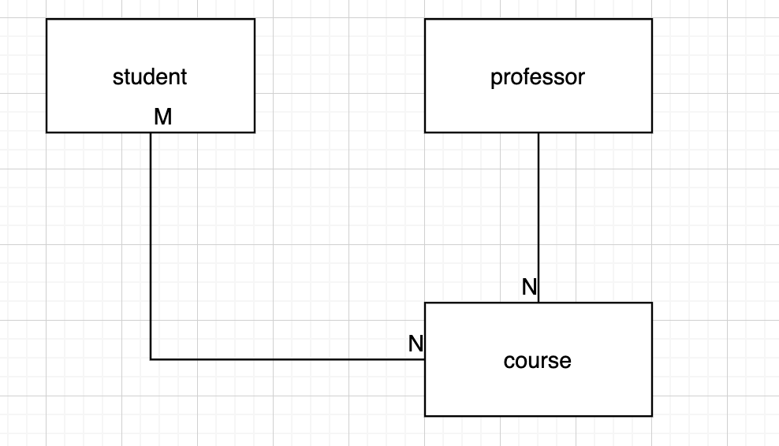

**Logical Model**

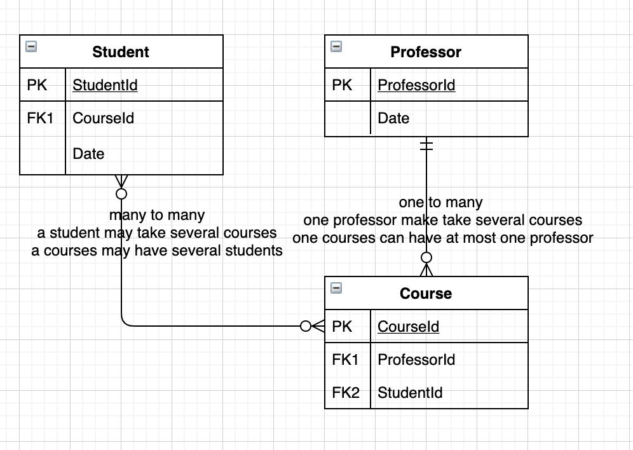

**Physical Mode**

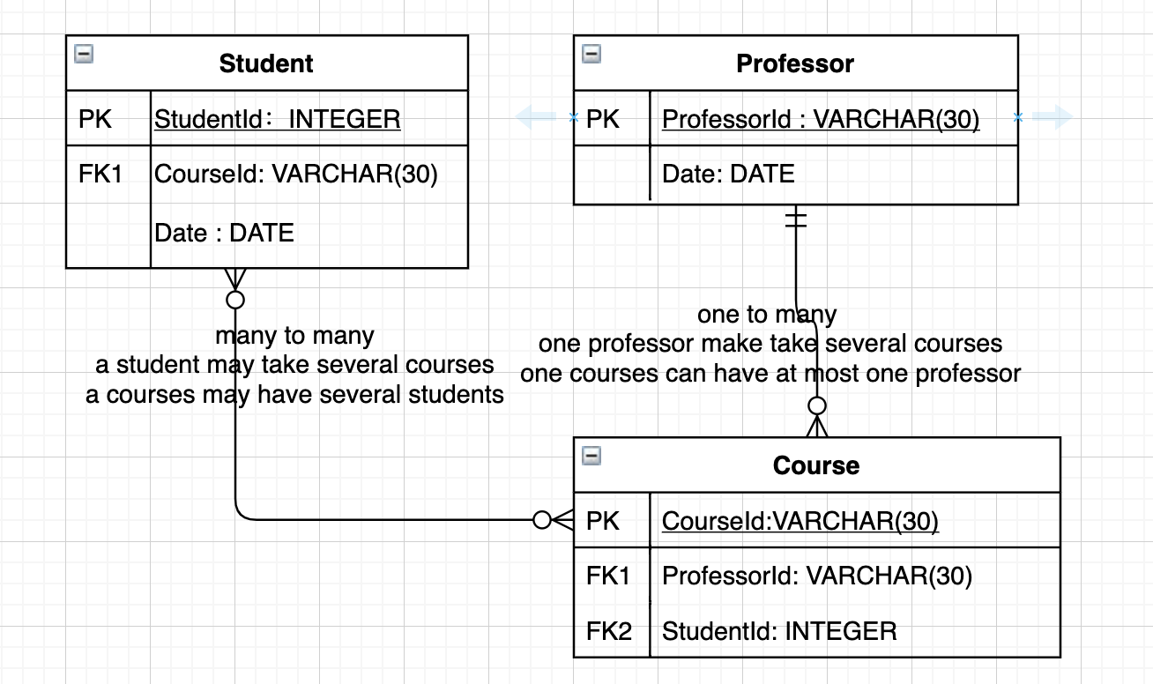

4. Insert a table that might occur in the relational database version of your ER diagram. What is an example of a key-constraint in this instance?

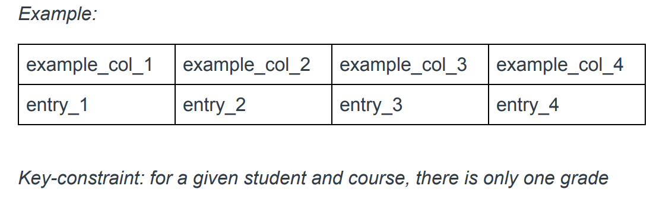

|  |  |  |  |
| --- | --- | --- | --- |
| studentId | ProfessorId | CourseId | Grade |
| 111 | AA1001 | Bio1000 | A |
| 111 | BB2001 | Chem1000 | A |
| 222 | AA1001 | Bio1000 | B |
| 222 | AA1001 | Math1000 | C |

Key-constraint:

Each student has a unique student id

Each course has a unique course id

Each professor also has a unique professor id.

The ids can be considered as the Primary key respectively.

For a given student and course, there is only one grade

For a given course, there is only one professor

5. What is the difference between a query language and a programming language?

In a programming language) we write lines of code that perform one operation after another until the program completes its tasks. It used to solve some problems. Also, Programming languages usually are imperative

Query languages are aimed to manipulate data. on the other hand, is a query language in that we tell SQL what you want to do without specifying exactly how to accomplish the task. The DBMS decides the best way to perform the job. In other word, query languages are usually declarative.